A Project Proposal on

**“Custom Pc Builder based on Games and Application user wants to use”**

Submitted by

**Shubham Jadhav – 19202A0011**

**Shourish Kothawale – 19202A0047**

**Shishir Nath – 19202A0054**

**Piyush– 19202A0006**

Head of the Department

**Mrs. Yogita Jore**

**Department of Information Technology**

(NBA Accredited)

**Vidyalankar Polytechnic**

**Wadala (E), Mumbai – 400 037**

**Maharashtra State Board of Technical Education, Mumbai**

**2021 – 22 2020**

**________________**

**Abstract**

***In today’s world where power means better fps better performance better Quality custom pc plays a vital role!***

Building your own PC is the best solution for those who want full control over every aspect of their build. It provides the most thorough customization options, from the CPU to the fans and lighting. That means you'll always have the exact hardware you need.

We will create a software Application using which user can easily build custom pc based on his requirements (Games user want to play or applications he wants to use like adobe Designer for graphic designers), platform (Amd or Intel), Budget.

We will also take data from users and using data science we can create graph of the most played games and using that we can recommend some prebuild pc and components.

# Users

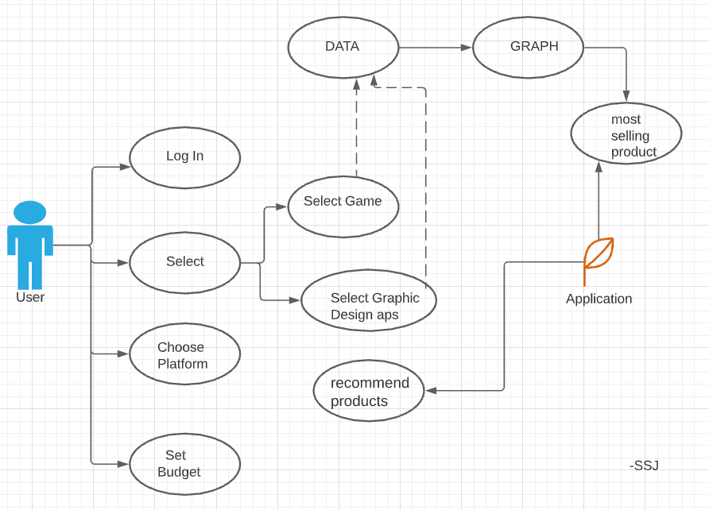

# 2. Flow chart / Block Diagram (if any needed to explain the topic)

# 2. Applications of the project

In today’s modern era Computer plays a vital role in our day-to-day life. computers are not only used in educational, gaming and entertainment but also in different fields like defence, medicine, business, communication and many more.

The quality of performance and life of the computer depends on its configuration. Most important aspects of a configuration are the speed of the processor, speed and stability provided by the motherboard, speed and size of storage, graphical display, and software drivers

What our project will provide is

***“BEST BUILD BY GAMES, SOFTWARE APPLICATION, RESOLUTION, PLATFORM!”***

We will also create a graph using data science and recommend few of our best products.

# 3. Technologies used for the project

* Data Science using python
* Software application using JAVA
* PostgreSQL

# 4. Reference Paper (in any)

# 5. Letter of Project Allocation (in case of Industry Project)